**Laptop Request Catalog Item**

Team ID : NM2025TMID13822

Team Size : 4

Team Leader : PRIYADHARSHINI B

Team member : GUNASEKARAN J

Team member : PRAKASH D

Team member : JAYAKUMAR B

# Problem Statement:

Employees in the organization need a quick and efficient way to request laptops for work. The current process is manual and prone to delays, with no dynamic form behavior to guide users or ensure accurate data collection. To address this, a Service Catalog item needs to be created, allowing users to easily request a laptop, with dynamic fields, clear instructions, and additional functionality like resetting the form if needed. The solution should also ensure all changes are tracked for governance and deployment.

# Objective:

Automate and streamline the laptop request process, reduce manual effort and potential delays, improve data accuracy through dynamic form behavior, provide a user-friendly experience with clear instructions, implement form reset functionality, and establish change tracking for governance and deployment.

Skills:UIPathRPA,Tanzu Application Service

# Create Local Update set

Open service now.

Click on All  >> search for update sets

Select local update sets under system update sets

Click on new

Fill the following details to create a update set as: “Laptop Request”

Click on submit and make current

By clicking on the button it activates the update set .

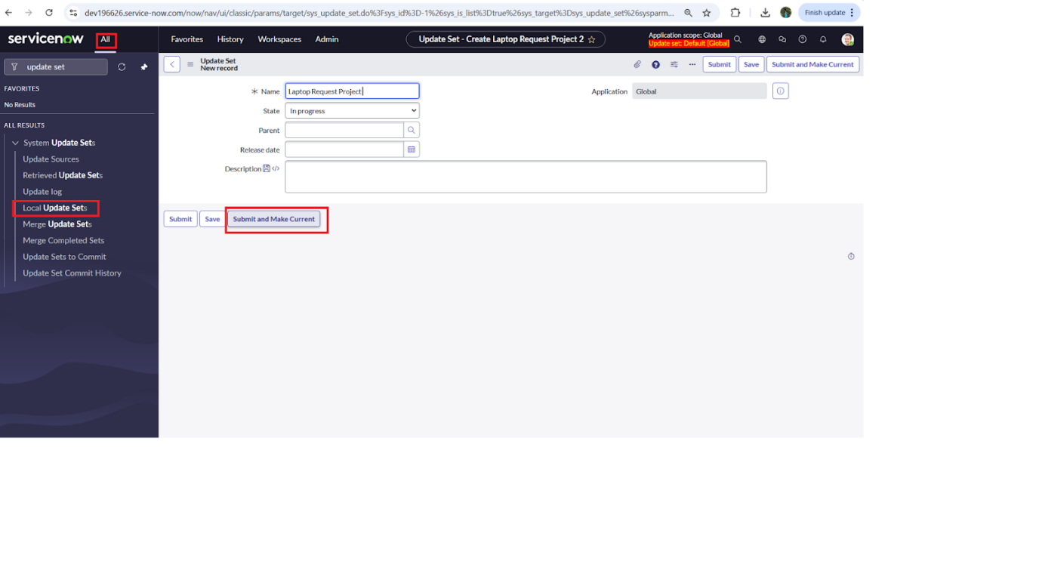

NOTE: Perform all actions under this newly created update set only.

# Create Service Catalog Item

Open service now.

Click on All  >> service catalog

Select maintain items under catalog definitions

Click on New.

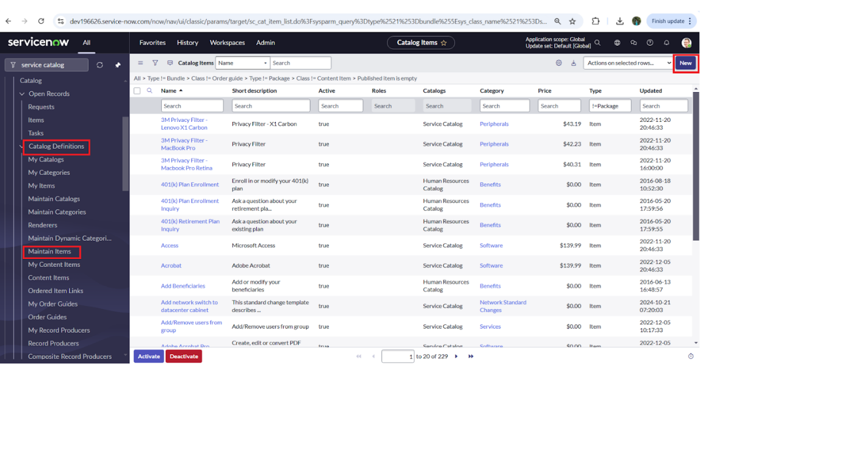

Fill the following details to create a new catalog item

            Name: Laptop Request

            CatLog: service CatLog

            Category: Hardware

            Short Description: Use this item to request a new laptop

Click on ‘SAVE’

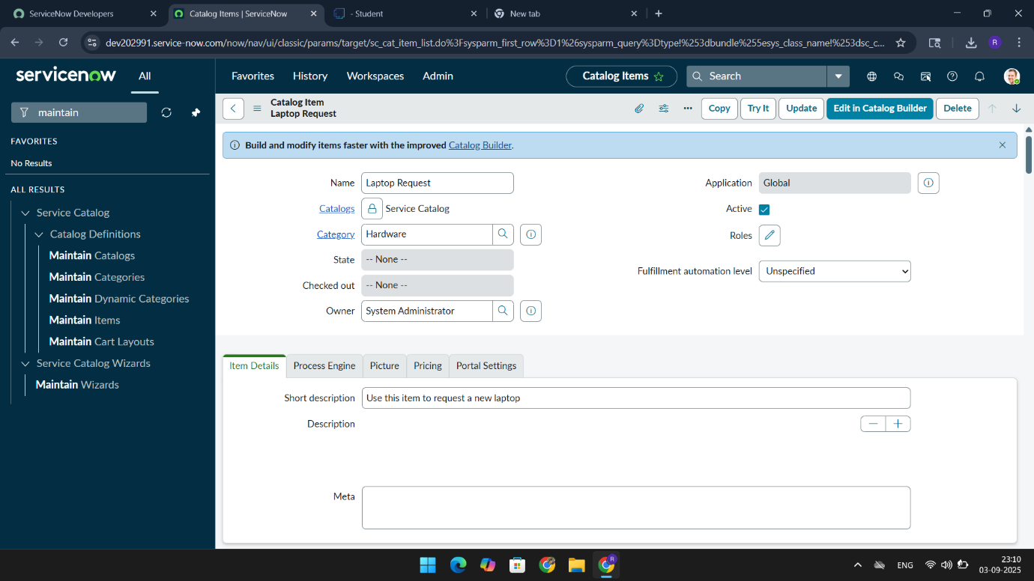

# Add variables

**Step1:**

* After saving the catalog item form scroll down and click on variable(related list)
* Click on new and enter the details as below

1. Variable 1:Laptop Model

             Type: Single line text

             Name: laptop_model

             Order:100

* Click on submit
* Again click on new and add Remaining variables in the above process

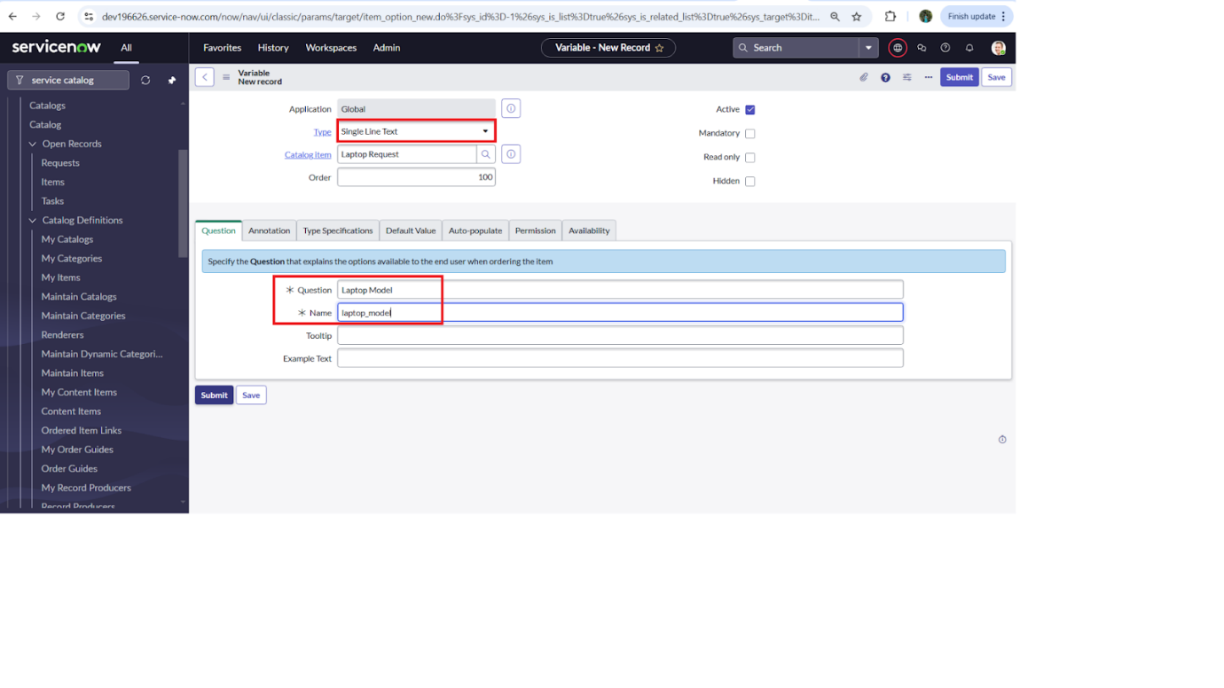

     2. Variable 2:Justification

             Type: Multi line text

             Name: justification

             Order:200

     3. Variable 3:Additional Accessories

             Type: Checkbox

             Name: additional_accessories

             Order:300

     4. Variable 4: Accessories Details

             Type: Multi line text

             Name:accessories_details

             Order:400

**Step2:**

* After adding above variable which are added to newly created catalog item
* Then save the catalog item form

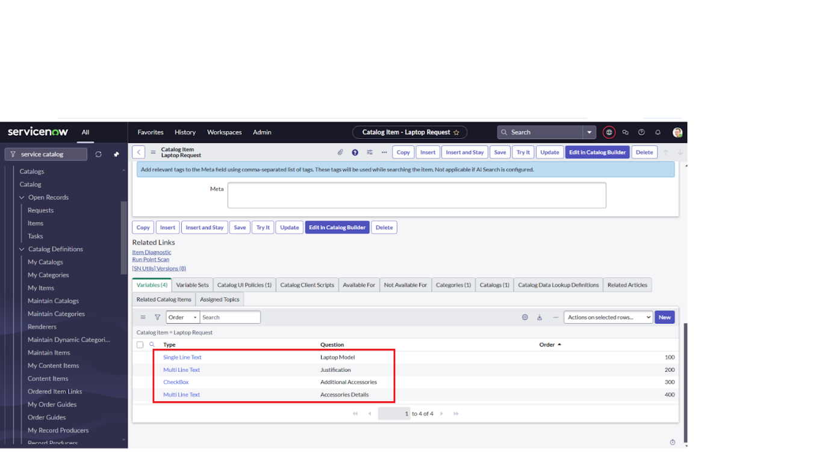

# 

# Create Catalog Ui policies

Click on all>> search for service catalog

Select maintain item under catalog definition

Search for ‘laptop request’ which is created before

Select ‘laptop request’ and scroll down click on “Catalog Ui policies”

In the catalogui policies related list tab click on new

Give short description as: show accessories details

Set the Catalog Condition in the related list tab ‘when to apply’

                  [field: additional_ accessories, operator: is, value: true]

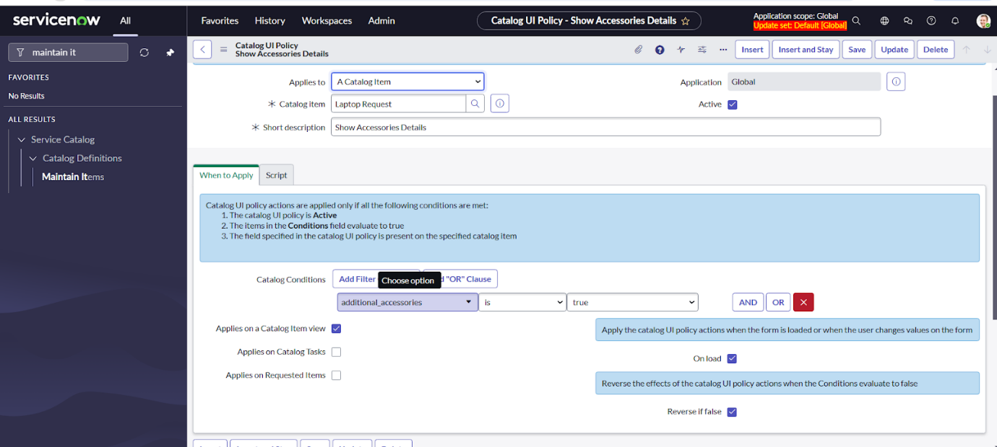

Click on save.(do not click on submit)

Scroll down and select ‘catalogui action’

Then click on new button

Select variable name as: accessories_details

                              Order:100

                    Mandatory: True

                         Visible : True

Click on save and again click save button of the catalogui policy form

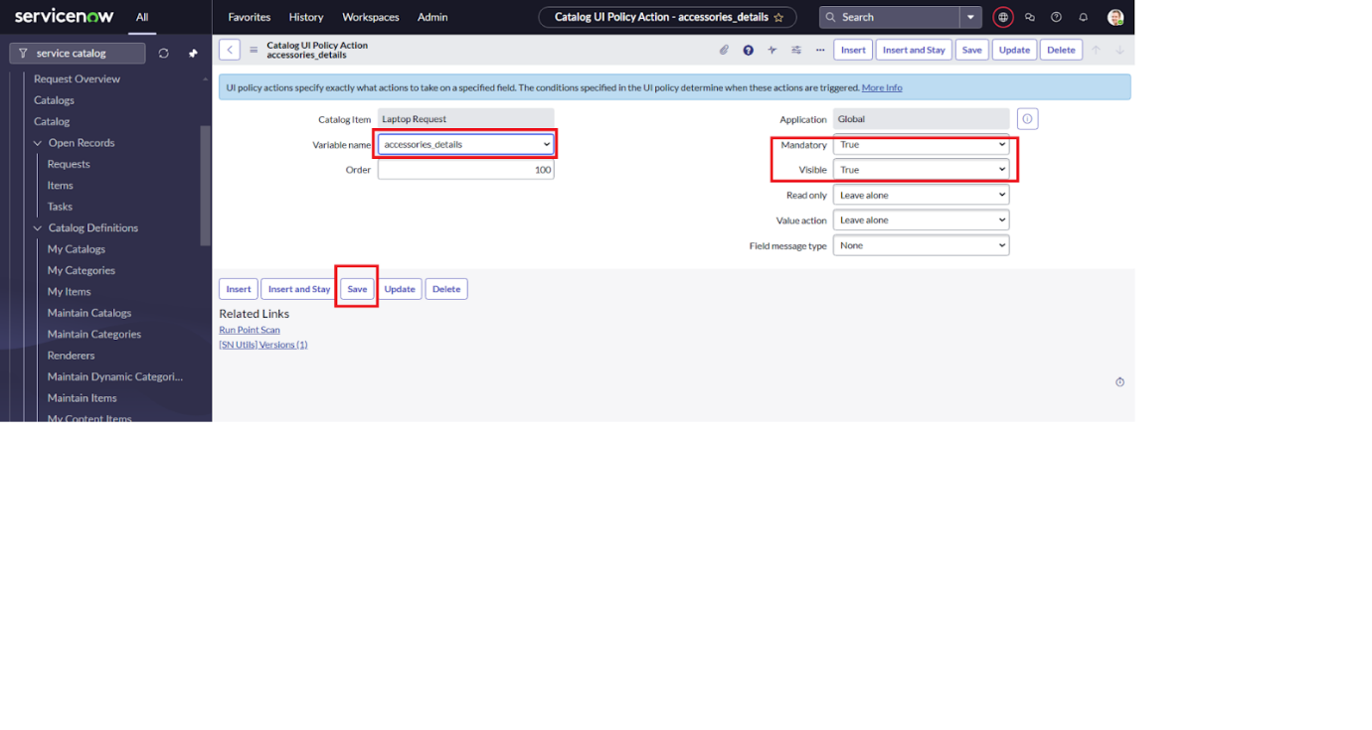

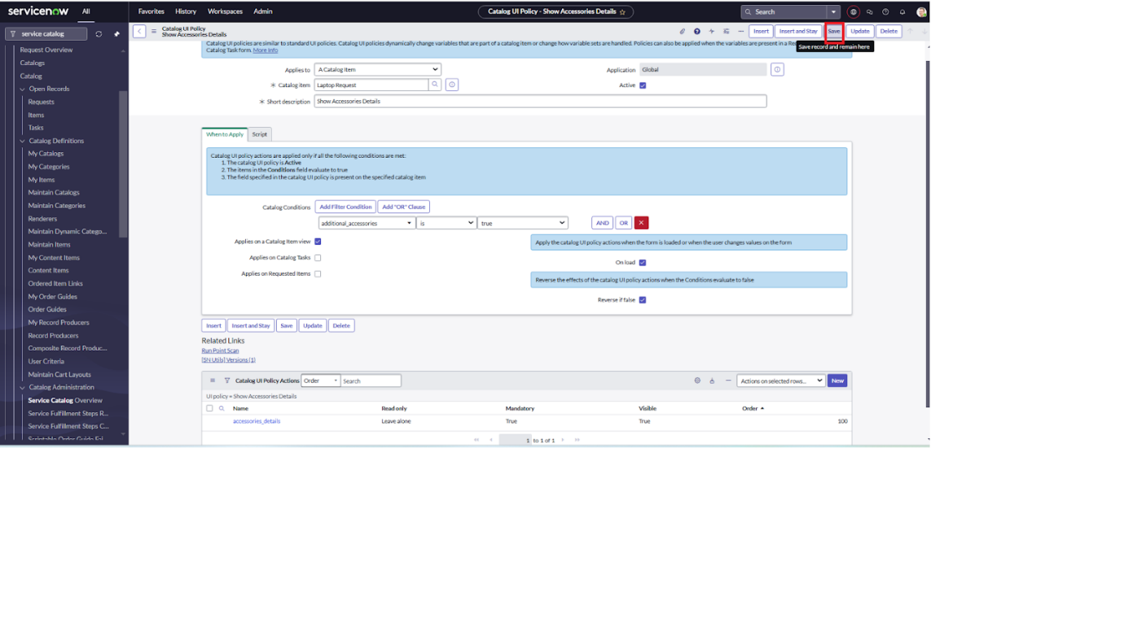

# Create ui action

1. Open service now.
2. Click on All  >> search for ui action
3. Select ui actions under system definition
4. Click on new
5. Fill the following details to create ui action

              Table: shopping cart(sc_cart)  
              Order:100  
              Action name:  Reset form  
               Client : checked  
Script:  
    function resetForm() {  
    g_form.clearForm(); // Clears all fields in the form  
    alert("The form has been reset.");  
}  
  
Click on save

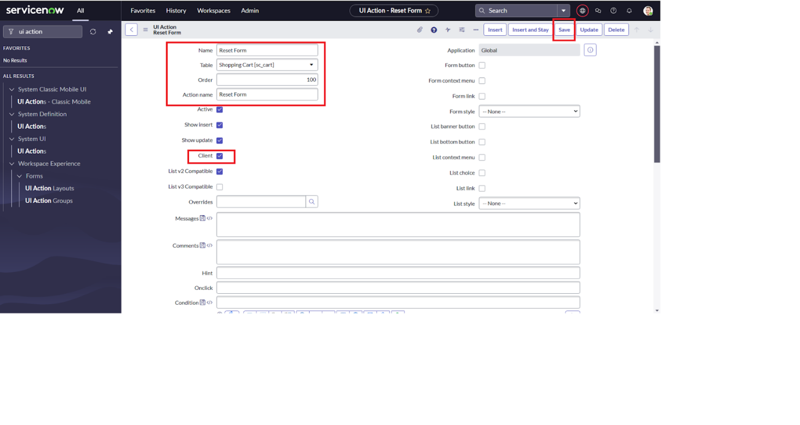

## Exporting changes to another instances

1. Click on All  >> search for update sets
2. Select local update set
3. Select created update set i.e. ‘Laptop Request Project’
4. Set the state to ‘Complete’
5. In the related list Update tab, updates are visible which we perform under this update set.
6. Click on export to XML ,itdownload one file

# Retrieving the update set

1. Open another instance in incognito window
2. Login with credentials
3. Click on all>> search for update sets
4. Select “Retrieved update set” under system update set
5. It open retrieved update set list and scroll down
6. Click on Import update set from XMLA screenshot of a computer

   AI-generated content may be incorrect.
7. Upload the downloaded file in XML file
8. Click on Upload and it gets uploaded.A screenshot of a computer

   AI-generated content may be incorrect.
9. Open retrieved update set ‘laptop request project’
10. Click on preview update set
11. And click on commit update set
12. And also see the related tab updates
13. After commiting update set in this instance we get all updates which are done in the previous instance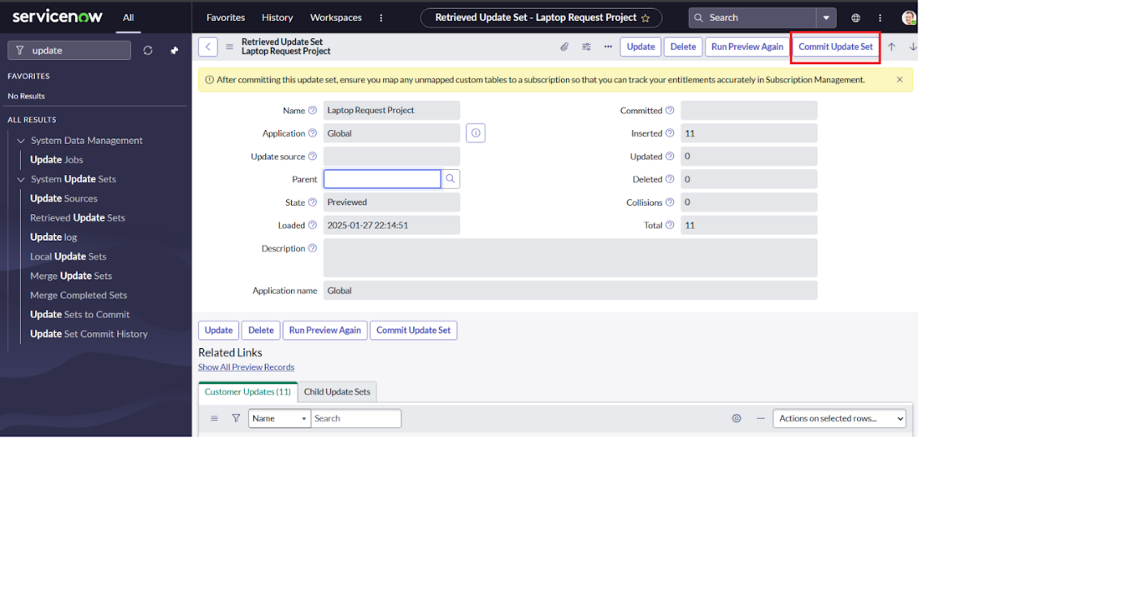

# Test Catalog Item

1. Search for service catalog in application navigator in target instance
2. Select catalog under service catalog
3. Select  hardware category and search for ‘laptop request’ item
4. Select laptop request item and open  it
5. It shows three variables onlyA screenshot of a computer

   AI-generated content may be incorrect.
6. As per our scenario, when we click on additional accessories checkbox then accessories details fields is visible and that should be mandatory
7. Now  see the results,itfulfills our requirements.A screenshot of a computer

   AI-generated content may be incorrect.

# Conclusion :

 The Laptop Request Catalog Item project successfully streamlines the process of requesting laptops within the organization by leveraging ServiceNow's Service Catalog capabilities. Through the implementation of a dynamic catalog item, the project ensures that users have an intuitive and user-friendly interface, reducing errors and improving efficiency.This project demonstrates how ServiceNow can be used to replace manual, error-prone processes with automated, efficient, and user-centric solutions. It not only improves service delivery but also enhances employee satisfaction by providing a modern and streamlined request experience.